| **Test Name** | | | Play game | | | |
| --- | --- | --- | --- | --- | --- | --- |
| **Use Case Tested:** | | | Play Game-play new game | | | |
| **Test Description:** | | | Check that user can choose to play a game | | | |
| **Pre-conditions** | | | User must of logged in or have skipped login  Choose game panel must be open | | | |
| **Post-conditions** | | | User can play a new game | | | |
| **Notes:** | |  | | | | |
| **Result (Pass/Fail/Warning/Incomplete)** | | **Pass** | | | | |
|  | **TEST STEP** | | | **EXPECTED TEST RESULTS** | P | F |
|  | User presses new game button | | | A new game will open in game screen | P |  |

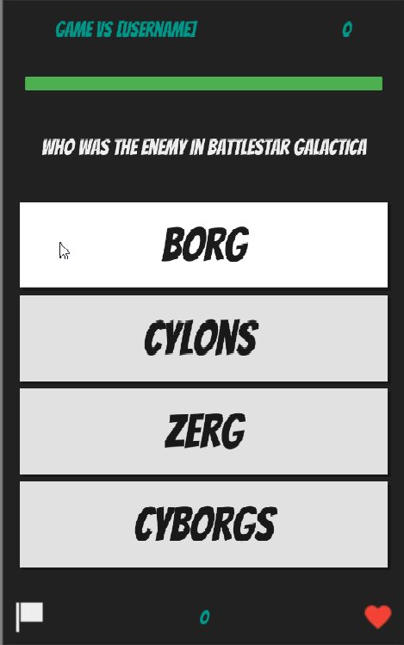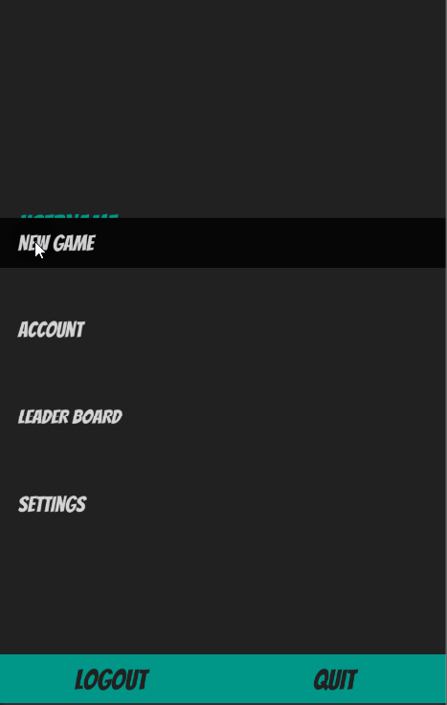

Pressing new game button Opens up game screen

| **Test Name** | | | Play game | | | |
| --- | --- | --- | --- | --- | --- | --- |
| **Use Case Tested:** | | | Play game-Answer question | | | |
| **Test Description:** | | | This test should make sure a user can answer a question | | | |
| **Pre-conditions** | | | User must have chosen either a pre-existing game or a new game  Game screen must be open | | | |
| **Post-conditions** | | | User should be able to answer a question | | | |
| **Notes:** | |  | | | | |
| **Result (Pass/Fail/Warning/Incomplete)** | | **Pass** | | | | |
|  | **TEST STEP** | | | **EXPECTED TEST RESULTS** | **P** | **F** |
| 1 | User reads displayed question and chooses answer | | | User should be able to select an answer | **p** |  |

|  |  |  |  |  |  |
| --- | --- | --- | --- | --- | --- |
| **Test Data Table** | | | | | |
|  | **1** | **2** | **3** | **4** | **5** |
| How tall is Yoda | 0.66 m | 1.2 m | 1.0 m | 0.5 m |  |

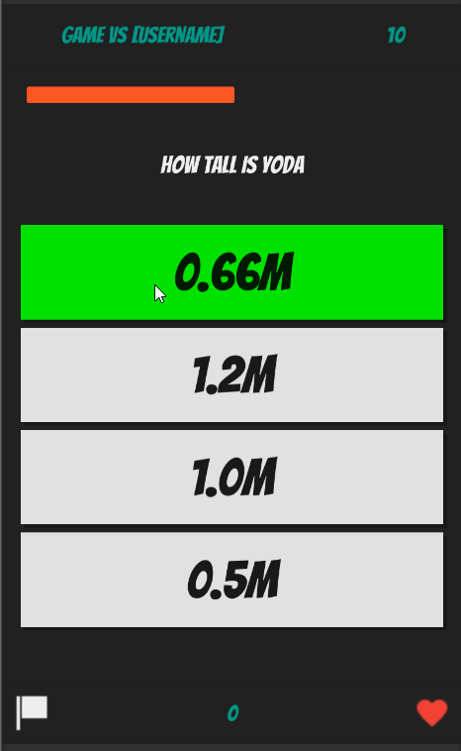

Showing correct answer as green and score of 10

| **Test Name** | | | Answer question | | | |
| --- | --- | --- | --- | --- | --- | --- |
| **Use Case Tested:** | | | Answer question- correct answer | | | |
| **Test Description:** | | | Verify that answering a question correctly adds points to Players score | | | |
| **Pre-conditions** | | | User must have chosen either a pre-existing game or a new game  Game screen must be open | | | |
| **Post-conditions** | | | Players score should increase 10 points every correct answer | | | |
| **Notes:** | |  | | | | |
| **Result (Pass/Fail/Warning/Incomplete)** | | **Pass** | | | | |
|  | **TEST STEP** | | | **EXPECTED TEST RESULTS** | **P** | **F** |
| 1 | Player answers question correctly | | | 10 points will be added to players score and answer button turns green | **p** |  |

|  |  |  |  |  |  |
| --- | --- | --- | --- | --- | --- |
| **Test Data Table** | | | | | |
|  | **1** | **2** | **3** | **4** | **5** |
| What is the name of the protocol droid that greets Qui-Gon and Obi-Wan on the Trade Federation flagship? | TC-14 | Score 20 |  |  |  |
| How tall is Yoda? | 0.66 | Score 30 |  |  |  |

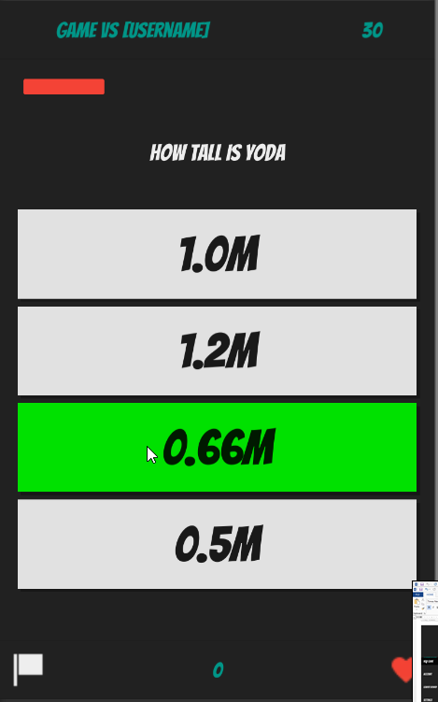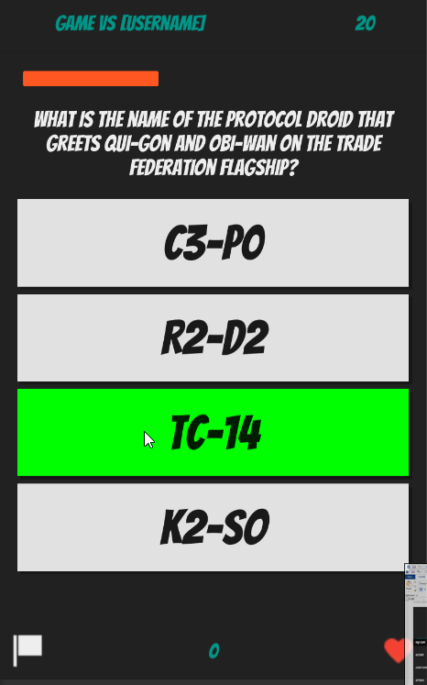

| **Test Name** | | | Play game | | | |
| --- | --- | --- | --- | --- | --- | --- |
| **Use Case Tested:** | | | Answer question- incorrect answer | | | |
| **Test Description:** | | | Verify that answering a question incorrectly subtracts points from players score | | | |
| **Pre-conditions** | | | User must have chosen a new game  Game screen must be open | | | |
| **Post-conditions** | | | Players score should decrease 5 points every incorrect answer | | | |
| **Notes:** | |  | | | | |
| **Result (Pass/Fail/Warning/Incomplete)** | |  | | | | |
|  | **TEST STEP** | | | **EXPECTED TEST RESULTS** | **P** | **F** |
| 1 | Player answers question incorrectly | | | 3 points will be decreased from players score and wrong answer turns red with correct answer being shown to player by turning green |  |  |

|  |  |  |  |  |  |
| --- | --- | --- | --- | --- | --- |
| **Test Data Table** | | | | | |
|  | **1** | **2** | **3** | **4** | **5** |
| Doc was shot in the back because of how much money? | $50 |  |  |  |  |

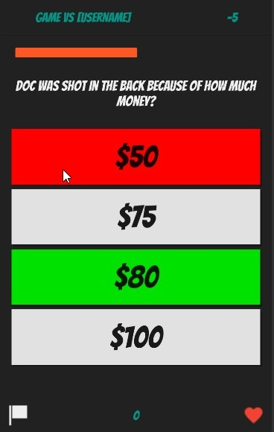

Wong answer shown red -5 points score and correct answer shown in green

| **Test Name** | | | Play game | | | |
| --- | --- | --- | --- | --- | --- | --- |
| **Use Case Tested:** | | | Play round-Timer stops round | | | |
| **Test Description:** | | | Verify that round timer works | | | |
| **Pre-conditions** | | | User must have chosen either a pre-existing game or a new game  Game screen must be open | | | |
| **Post-conditions** | | | Timer bar should decrease till time runs out | | | |
| **Notes:** | |  | | | | |
| **Result (Pass/Fail/Warning/Incomplete)** | |  | | | | |
|  | **TEST STEP** | | | **EXPECTED TEST RESULTS** | **P** | **F** |
| 1 | Question should be displayed with answers | | | Timer bar at top should decrease till no time left and stop round |  |  |

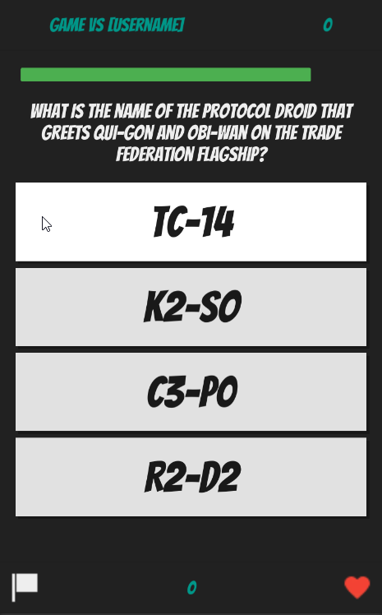

Timer bar green nearly full Timer bar less and turned red



Timer red and less still on both screenshots

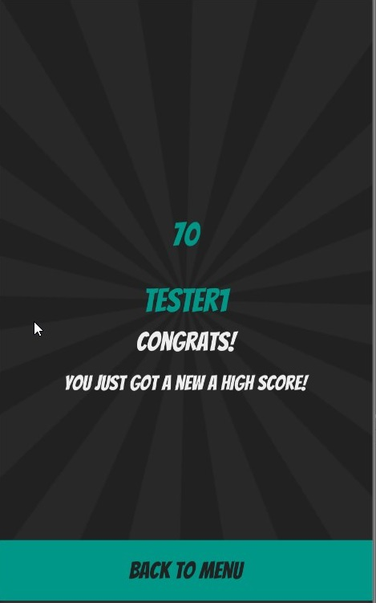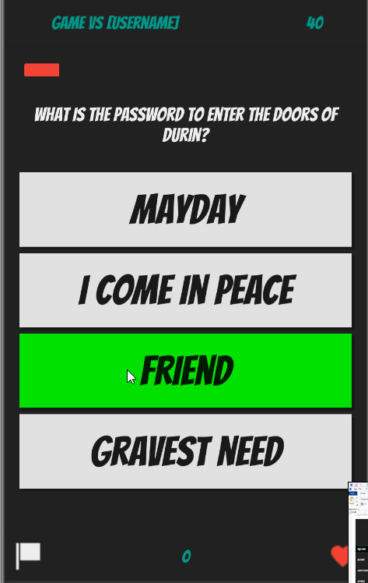

Timer bar nearly gone Timer ran out end of round screen displays

| **Test Name** | | | Play game | | | |
| --- | --- | --- | --- | --- | --- | --- |
| **Use Case Tested:** | | | Play round-Submit score | | | |
| **Test Description:** | | | Verify that score is submitted at the end of rounds and game | | | |
| **Pre-conditions** | | | User must finished a round or game  Game screen must be open | | | |
| **Post-conditions** | | | Score should be submitted to database. | | | |
| **Notes:** | |  | | | | |
| **Result (Pass/Fail/Warning/Incomplete)** | | **Pass** | | | | |
|  | **TEST STEP** | | | **EXPECTED TEST RESULTS** | **P** | **F** |
| 1 | User finishes a round and score submits to database if it is the users highest score | | | Score should be submit to the database. | **P** |  |

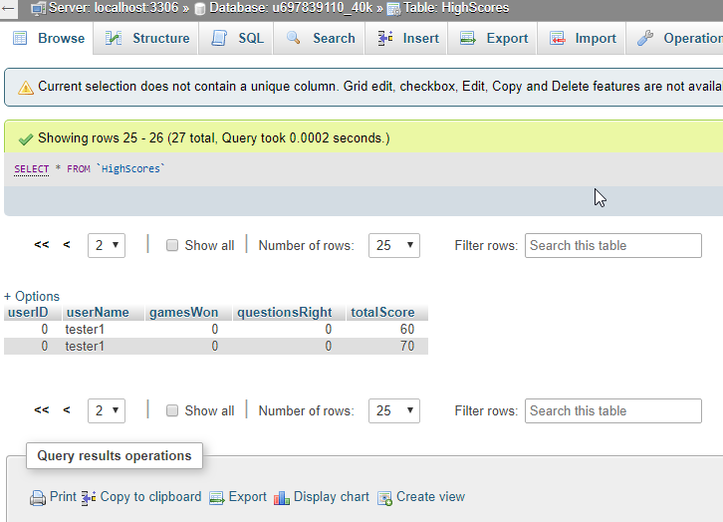



Tester1 gets a new high score Database showing tester1’s high score